Nepal College of Information Technology
Assessment-2009*

Program: ELX Time: 2 hrs
Semester: Spring(VI) FM: 100
Subject: Industrial Electronics and Drives PM: 50

1. a) Describe the working of a Diac with the help of its V-I characteristics. [8]
b) A silicon UJT has an interbase resistance of 10K. It has R_{B1}=6K I_{E}=0. Calculate (i) UJT current if V_{BB}=20V and V_{E} is less than V_{P}, (ii) η and V_{A} and (iii) peak point voltage, V_{P}. [7]
2. a) What is freewheeling diode and why it is necessary? Explain the operation of single phase semi-converter with waveforms. [8]
b) A voltage source e=100 sin 377t supplies a resistive load of 100Ω through a thyristor, which perform half-wave controlled rectification. Calculate the average power in the load, if the firing angle is fired at 45⁰, with respect to the supply voltage waveform. [7]
3. a) With the help of circuit diagram and associated waveform, explain the working of class C chopper drives. [8]
b) In a two quadrant chopper circuit is used to control the speed of dc motor and also for regenerative braking of motor. The motor constant is KaФ=0.1V/rpm. The chopping frequency is f_{c}=250Hz and motor armature resistance is Ra=0.2 Ω. The supply voltage is 120V. At N=400rpm and I_{o}=100A (i) Determine the turn on time t_{on} of the chopper and (ii) Find the power developed by the motor power absorbed by Ra. [7]
4. a) Derive the expression for current and voltages across commutating elements of a basic series inverter. [8]
b) With the suitable external configuration of IC 555 timer, explain the astable mode of operation. [7]
5. a) How do you protect a thyristor from high dv/dt and high di/dt. Explain with suitable circuit diagram. [6]
b) A 210V, 1200rpm, 10A separately excited motor is controlled by a single-phase fully controlled converter with an ac source voltage of 230V, 50Hz. Assume that sufficient induction is present in the armature circuit to make the motor current continuous and ripple free. Armature resistance Ra= 1.5Ω
i) What should be the value of the firing angle to get the rated torque at 800rpm?
ii) Compute the firing angle for the rated braking torque at -1200rpm.
iii)Calculate the motor-speed at the rated torque and α =165⁰ for the regenerative braking mode. [9]
6. a) Develop a ladder diagram that provides for the motor process described in below figure.
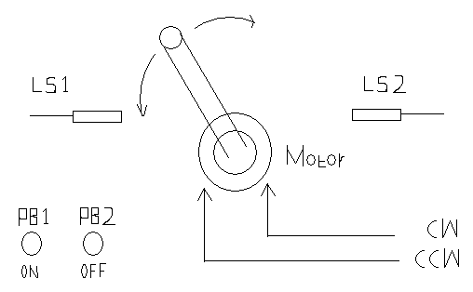
Process:
When the system is turn ON, the motor is to alternate rotation Clockwise (CW) and Counter Clockwise (CCW). When the system is turn OFF Motor should stop. LS1 and LS2 are the limit switch to indicate the maximum position for CCW and CW rotation respectively. [10]
b) Draw the PLC ladder diagram of the following Truth Table [5]

A | B | C | Y
0 | 0 | 0 | 0
0 | 0 | 1 | 0
0 | 1 | 0 | 0
0 | 1 | 1 | 1
1 | 0 | 0 | 0
1 | 0 | 1 | 1
1 | 1 | 0 | 1
1 | 1 | 1 | 1

7. Write short notes on (any two) [5*2=10]
a) Dual Converter
b) Phase controlled thyristor
d) Reed Relay

